-- Write SQL statement for the following
-- 1. To find all managers with salary >1500
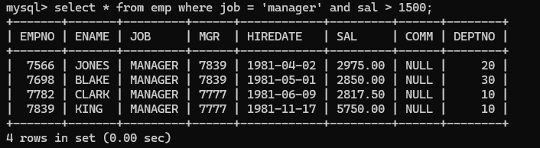
select * from emp where job = 'manager' and sal > 1500;

-- 2. list all employees with sal >1200 and < 2000

select * from emp where sal between 1200 and 2000;
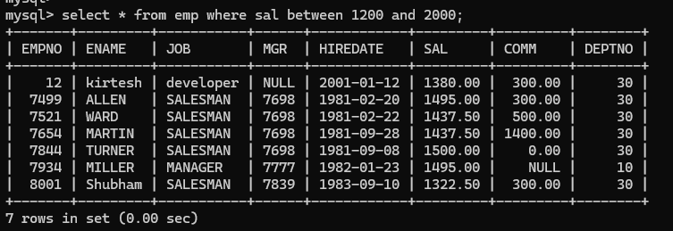-- 3. list all employees with sal is 1600 or sal is 800 or sal is 1900
select * from emp where sal in (1600,800,1900);
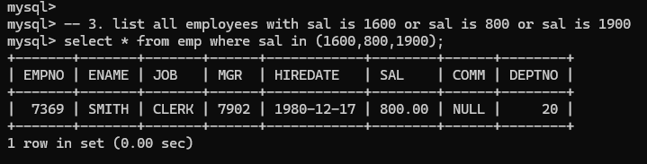-- 4. list all employees with R at second last position in name
select * from emp where ename like '%R_';

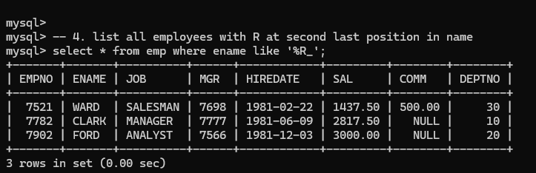
-- 5. List all employees with name starts with A and ends with N

select * from emp where ename like 'A%N';
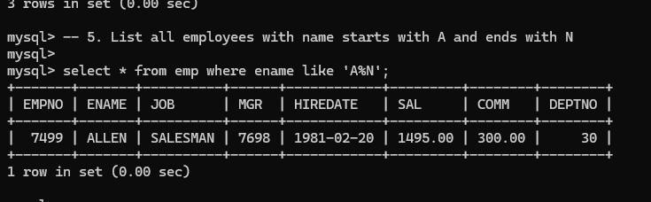
-- Q2. Solve following

-- 1. list all employees with salary > 1250 and dept no=30

select * from emp where sal > 1250 and deptno =30;
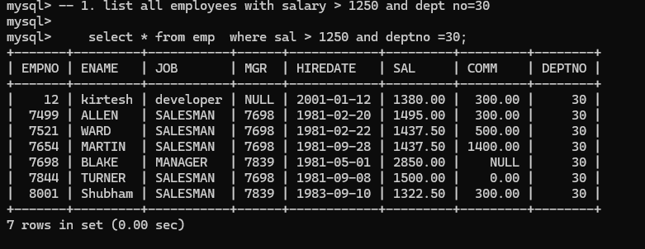
-- 2. list all employees with salary >=1250 and <= 3000
select * from emp where sal between 1251 and 3000;
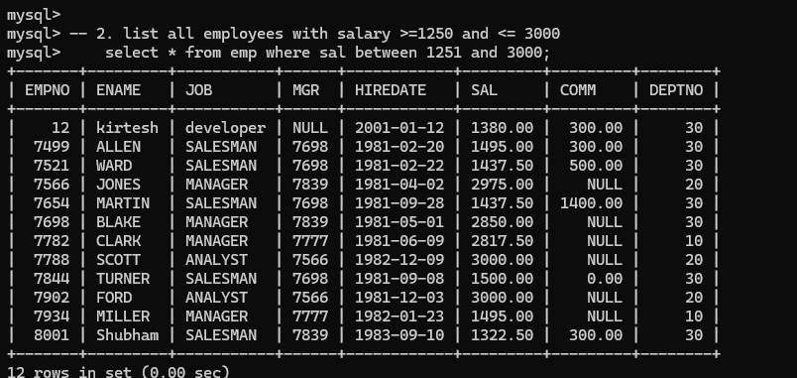
-- 3. list all employees with salary >1250 and < 3000
select * from emp where sal between 1250 and 3000;
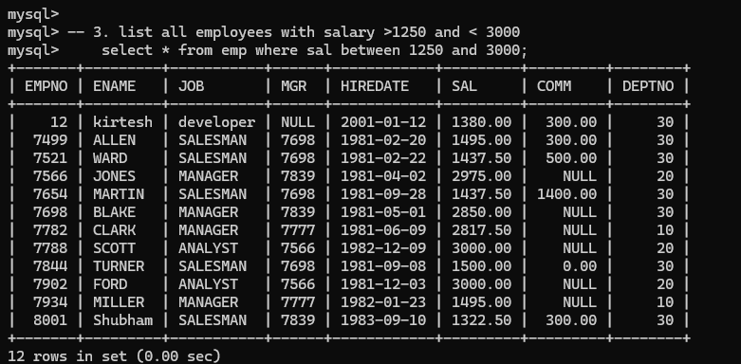
-- 4. list all employees with salary either equal to 3000 or 1250 or 2500
select * from emp where sal in (3000,1250,2500);
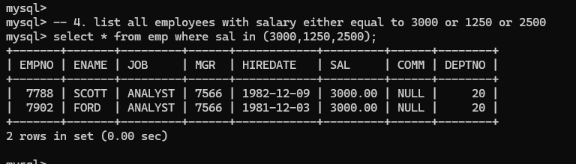-- 5. list all employee with name=SMITH
select * from emp where ename = 'smith';
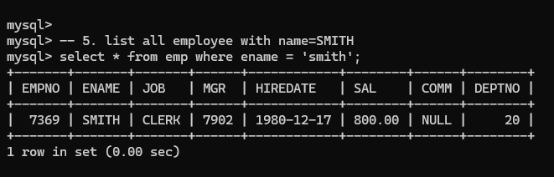
-- 6. list all employees with name starting with S
select * from emp where ename REGEXP '^S';
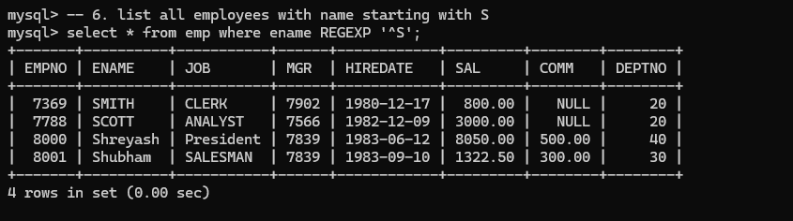
-- 7. list all employees with name ending with S
select * from emp where ename like '%S';
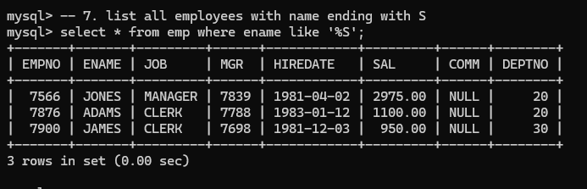-- 8. list all employees with name contains I at 2nd position
select * from emp where ename like '_I%';
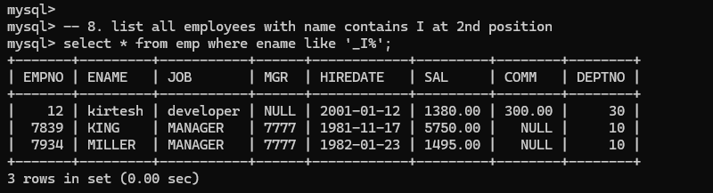

-- 9. list all employees with name starts with A ends witn N and somewhere in between L is there
select * from emp where ename like 'A%L%N';
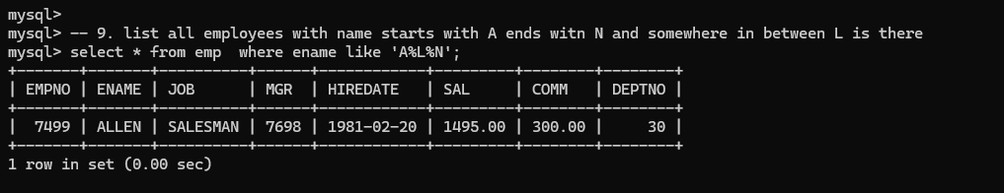

-- 10. list all employees with name starts with A and B at 3 rd position and P at second last position
select * from emp where ename like 'A_B%P_';
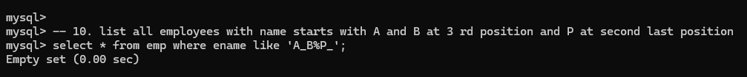

-- 11. List all employees with name starts with either A or starts with S or starts with W
select * from emp where ename like 'A%' or ename like 'S%' or ename like 'W%';
select * from emp where ename REGEXP '^[AS]';
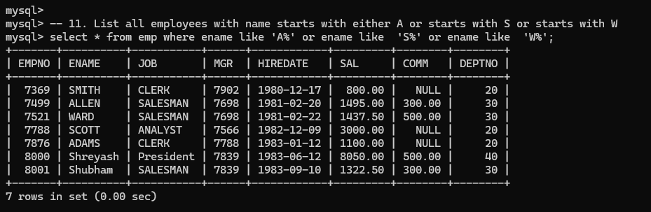
-- 12. find max sal and min sal for each job
select job, max(sal),min(sal) from emp GROUP BY job;
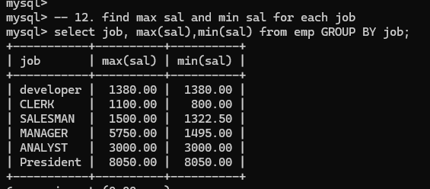
-- 13. find how many employess have not received commission
select count(*) from emp where comm is null;
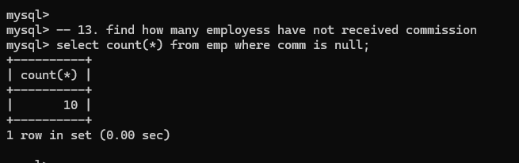

-- 14. find sum of sal of all employees working in dept no 10
select deptno,SUM(sal) from emp where deptno = 10;
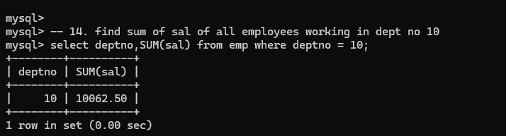

-- 15. find maximum salary,average sal for each job in every department

select job,MAX(sal), AVG(sal) from emp GROUP BY job;
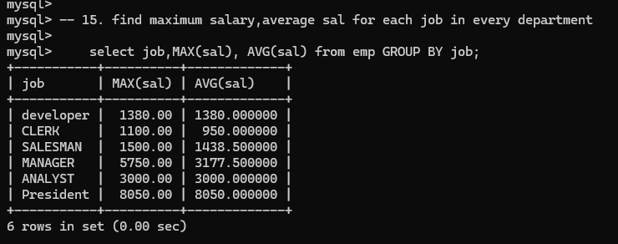

-- 16. find max salary for every department if deptno is > 15 and arrange data in deptno order.
select deptno, max(sal) from emp where deptno > 15
GROUP BY deptno
ORDER BY deptno;
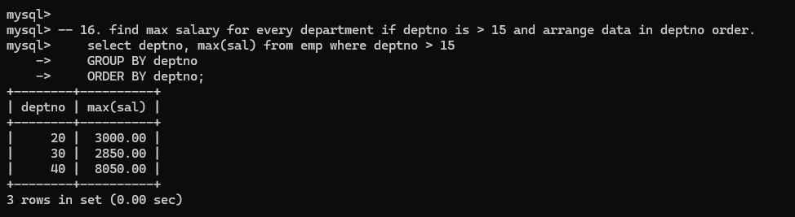

-- 17. find sum salary for every department if sum is > 3000
select deptno, sum(sal) from emp group by deptno HAVING SUM(sal) >3000;
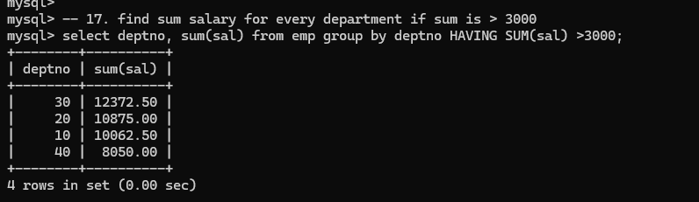-- 18. list all department which has minimum 5 employees
select deptno, count(empno) from emp GROUP BY deptno
HAVING count(empno) >5;
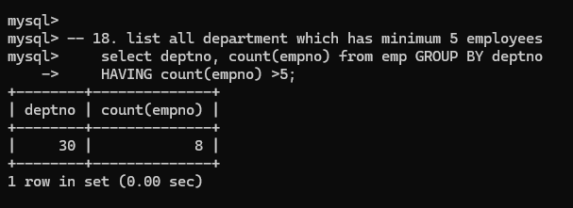
-- 19. count how many employees earn salary more than 2000 in each job
select job ,count(empno) from
emp where sal> 2000 GROUP BY job ;
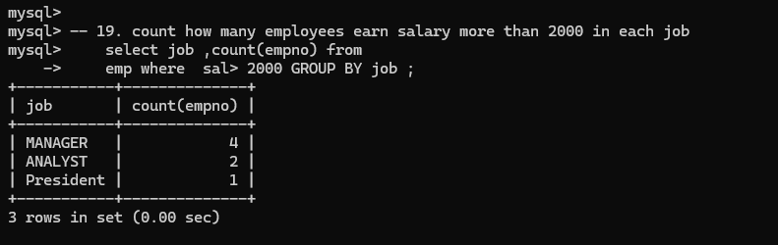

-- 20. list all enames and jobs in small case letter
select lower(ename),lower(job) from emp;
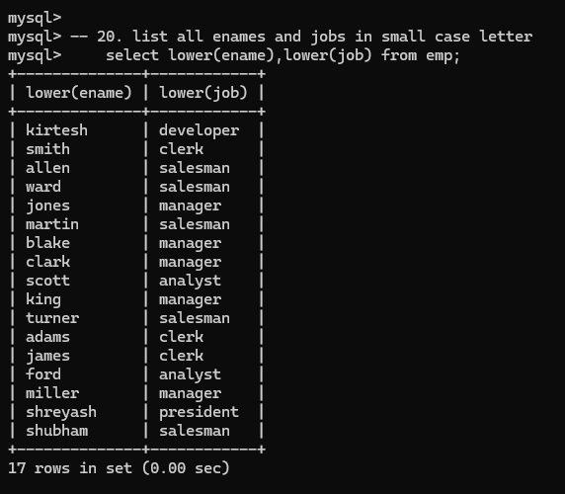
-- 21. list all names and jobs so that the length of name should be 15 if it is samller then add
-- spaces to left

select LPAD(ename,15,'-') from emp;
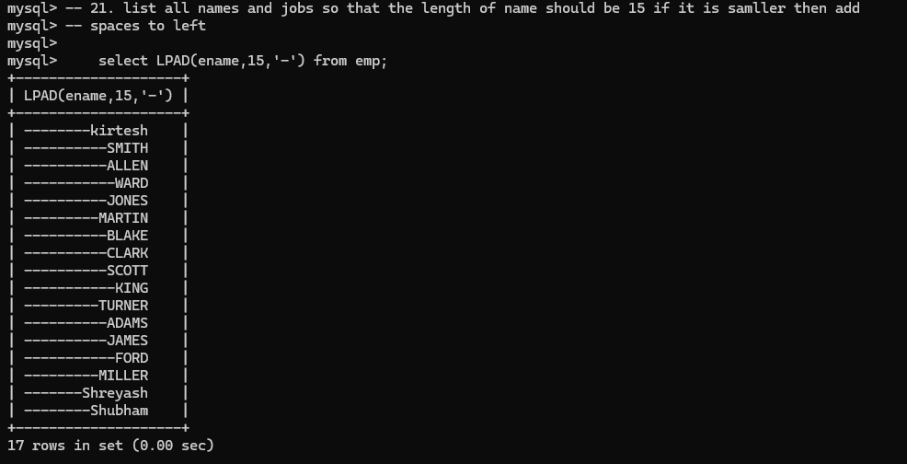

-- 22. display min sal,max sal, average sal for all employees working under same manager

select MIN(sal), MAX(sal) , AVG(sal) from emp group by mgr;
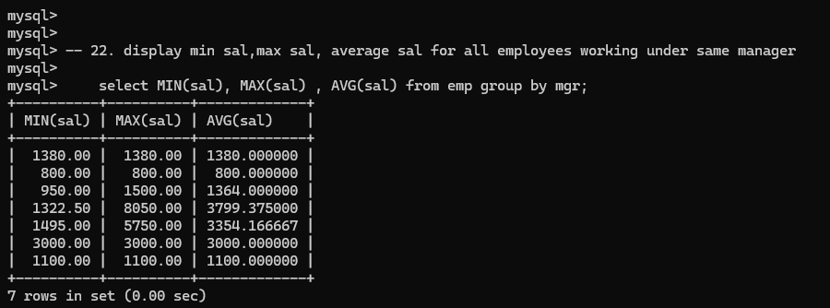

-- 23. find sum of total earnings(sal+comm), average of sal+comm for all employees who earn sal >-- 2000 and work in either dept no 10 or 20

select SUM(sal+comm), AVG(sal+comm) from emp where sal > 2000 and deptno in (10,20);
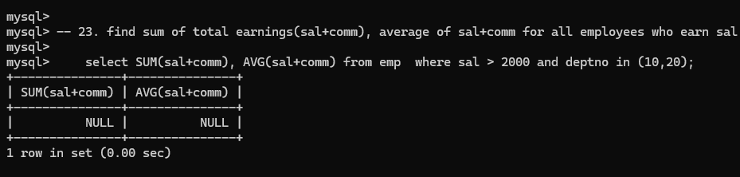
-- 24. list all employees who joined in Aug 1980 and salary is >1500 and < 2500

select date_format(curdate(),'%b');
select * from emp where date_format(hiredate, '%b %Y') in( date_format('1981-09','%b %Y')) and salary between 1500 and 2500;
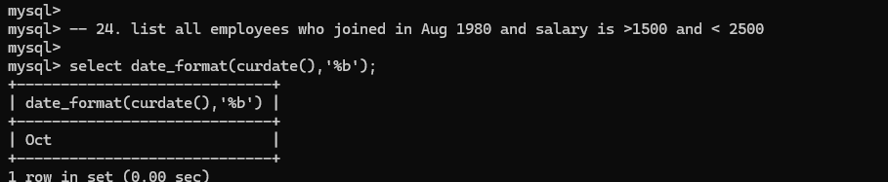

-- 25. list all employees joined in either aug or may or dec

select * from emp where date_format(hiredate, '%b') in ('Aug','May','Dec');
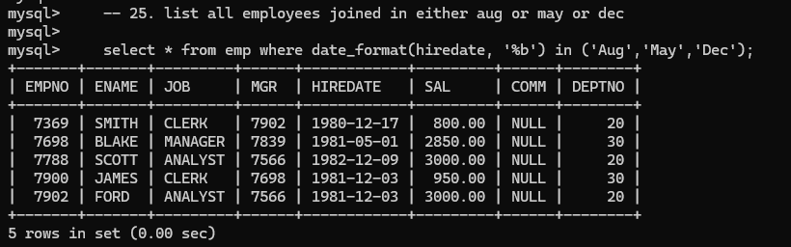

-- 26. display name and hiredate in dd/mm/yy format for all employees whose job is clerk and

-- they earn some commission
select ename, date_format(hiredate,'%d/%m/%Y') from emp where job = 'clerk' and comm is null ;
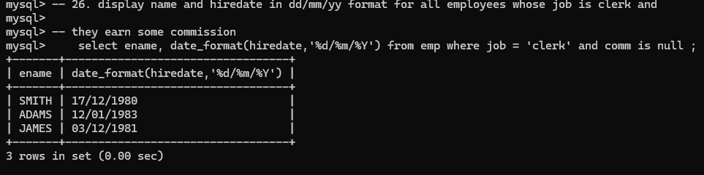

-- 27. list empcode,empno,name and job for each employee. (note :empcode is 3 to 5 characters
-- from name and last 2 characters of job)
select CONCAT(SUBSTR(ename,3,5),' ', right(job,2)) as EMPCODE ,ename ,job from emp;
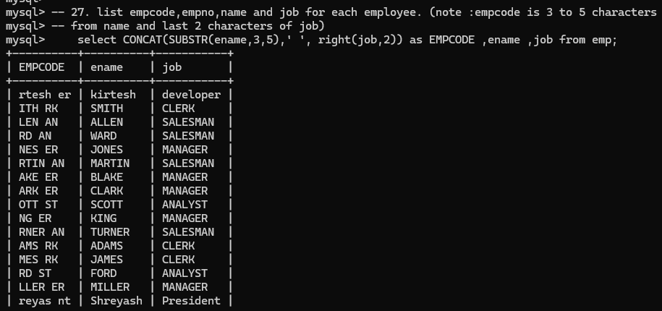
-- 28. display thousand separator and $ symbol for commission if it is null then display it as 0 for all employees whose name starts with A and ends with N

SELECT CONCAT('$', FORMAT(IFNULL(comm,0), 0)) as commision from EMP where ename like 'A%N';
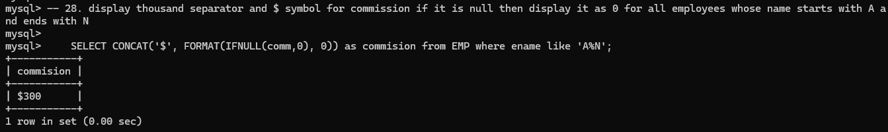
-- 29. Display empid,name,sal,comm,remark Remark should base on following conditions
-- comm >= 600 "excellent Keep it up"
-- if it < 600 or not null "good"
-- otherwise "Need improvement"

select empno,ename ,sal , comm,
CASE

WHEN comm>= 600 THEN 'Excellent'
WHEN comm < 600 or comm is not null then 'Good'
ELSE 'Need improvement'
END AS Remark
FRom EMP;
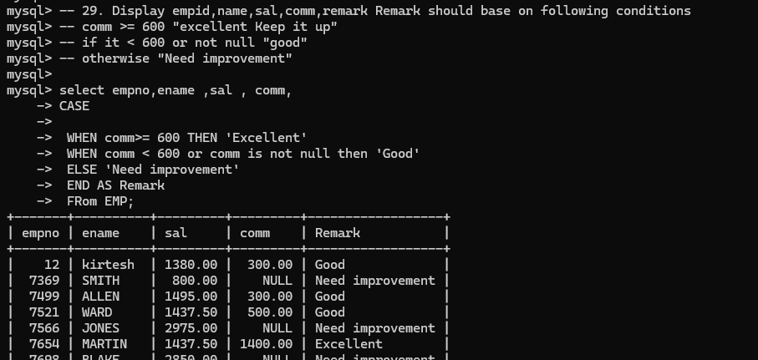
-- 30. Display empid, name, deptno and department name by using following conditions.
-- dept 10 then "Hr"
-- if 20 then "Admin"
-- if 30 then "accounts"
-- otherwise purchase
select empno,ename,e.deptno ,dname ,
CASE
WHEN e.deptno = 10 then 'HR'
WHEN e.deptno= 20 then 'ADMIN'
WHEN e.deptno= 30 then 'accounts'
ELSE 'Purchase'
end as Remarks
from emp e inner join dept d on e.deptno=d.deptno;
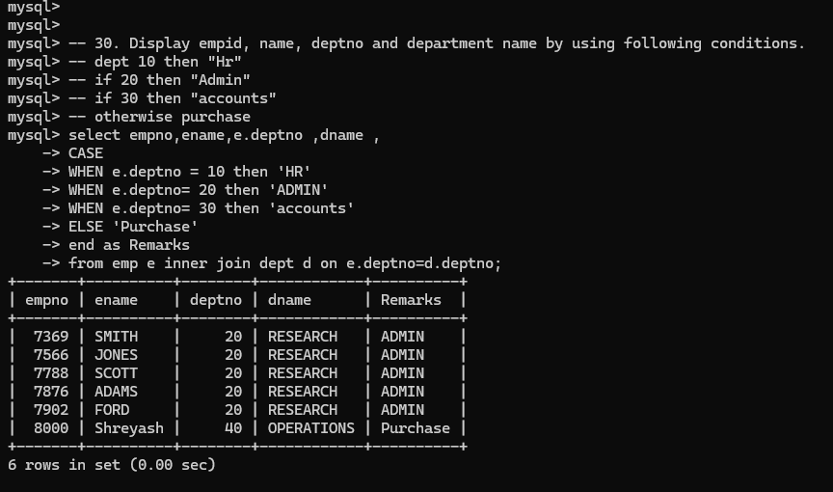-- 31. Practice creating following tables

-- create table mydept_DBDA
-- (deptid number primary key,dname varchar2(20) not null unique, dloc varchar2(20) )

create table mydept_DBDA(
deptid int PRIMARY KEY,
dname varchar(20) null unique,
dloc varchar(20)
)

-- insert into mydept_DBDA values(30,'Purchase','Mumbai');
-- create table myemployee

-- ( empno number(5) primary key, fname varchar2(15) not null, mname varchar2(15),
-- lname varchar2(15) not null, sal number(9,2) check(sal >=1000), doj date default sysdate,
-- passportnum varchar2(15) unique,
-- deptno number constraint fk_deptno references mydept_DBDA(deptid) on delete cascade )
create Table myemployee (
empno INT(5) PRIMARY key,
fname varchar(15) not null,
mname VARCHAR(15),
lname VARCHAR(15) not null,
sal DOUBLE(9,2) check(sal >=1000),
doj date DEFAULT (curdate()),
passportnum varchar(15) UNIQUE,
deptno int ,
constraint fk_deptno Foreign Key(deptno) REFERENCES DEPT(DEPTNO)
on Delete CASCADE

);

-- 32. Create following tables Student, Course

-- Student (sid,sname) ---------------- sid ---primary key
create table Student (
sid int PRIMARY KEY,
sname VARCHAR(15)
);

-- Course(cid,cname)-------------- cid ---primary key
CREATE TABLE Course(
cid int PRIMARY key,
cname VARCHAR(15)
);
-- Marks(studid,coursed,marks)

-- create table marks(
-- studid number,
-- courseid number,
-- marks number,
-- constraint pk primary key(studid,courseid),
-- constraint fk_sid foreign key (studid) references student(sid) on delete set null,
-- constraint fk_cid foreign key (courseid) references course(cid)
-- )
CREATE Table Marks(
studid int,
courseid int,
marks int,
constraint pk PRIMARY KEY(studid,courseid),

constraint fk_studid FOREIGN KEY(studid) REFERENCES Student(sid)
on delete CASCADE
,
constraint fk_courseId FOREIGN KEY(courseid) REFERENCES Course(cid)
);

-- Sample data for marks table
-- studid,courseid,marks
-- 1 1 99
-- 1 3 98
-- 2 1 95
-- 2 2 97
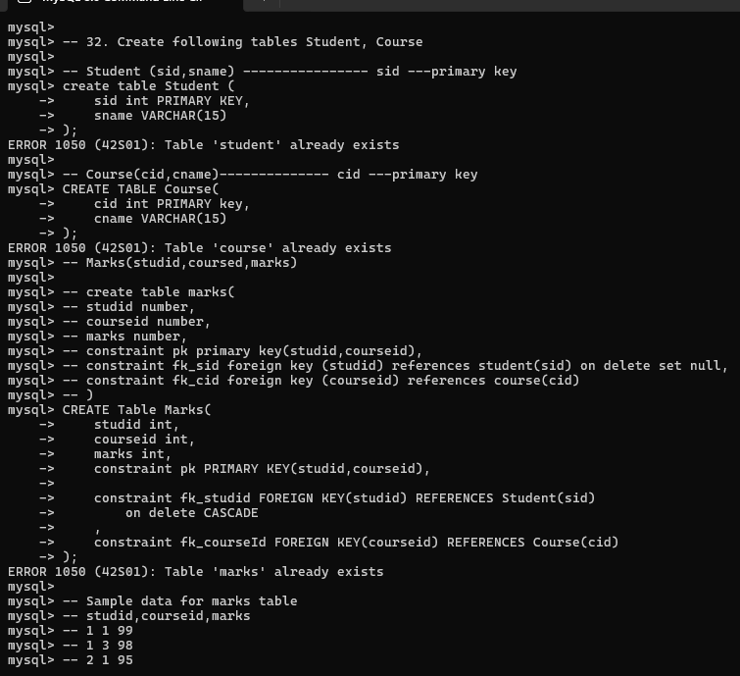
-- 33. Create empty table emp10 with table structure same as emp table.
-- create table emp10 as
-- (
-- select *
-- from emp
-- where 1=2;
-- )

-- 34. Solve following using alter table
-- add primary key constraint on emp,dept,salgrade
-- emp ----◊ empno
-- dept---◊ deptno
-- salgrade---◊ grade
-- add foreign key constarint in emp
-- deptno --->> dept(deptno)
-- add new column in emp table netsal with constraint default 1000

ALTER TABLE emp
ADD CONSTRAINT pk_emp PRIMARY KEY (empno);

ALTER TABLE dept
ADD CONSTRAINT pk_dept PRIMARY KEY (deptno);

ALTER TABLE salgrade
ADD CONSTRAINT pk_salgrade PRIMARY KEY (grade);

ALTER TABLE emp
ADD CONSTRAINT fk_emp_dept
FOREIGN KEY (deptno)
REFERENCES dept(deptno);

ALTER TABLE emp
ADD netsal DECIMAL(10,2) DEFAULT 1000;

-- 35. Update employee sal ---- increase sal of each employee by 15 % sal +comm, change the job

-- to manager and mgr to 7777 for all employees in deptno 10.
UPDATE EMP
SET
sal = (sal + IFNULL(comm,0)) * 1.15,
job = 'MANAGER',
mgr = 7777
WHERE deptno = 10;

-- 36. change job of smith to senior clerk

update EMP SET
job = 'senior clerk'
where ename = 'SMITH';

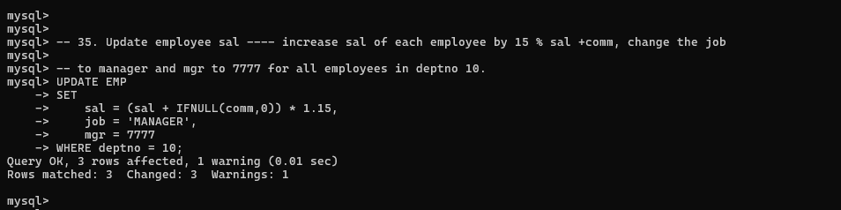
-- 37. increase salary of all employees by 15% if they are earning some commission

UPDATE EMP SET
sal = sal * 1.15
where comm is not null and comm > 0;
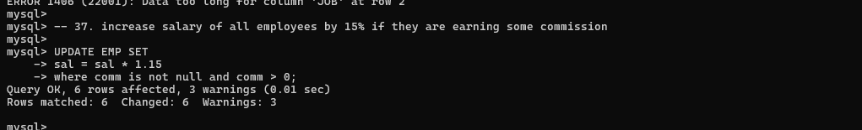
-- 38. list all employees with sal>smith's sal
SELECT * FROM EMP where sal > (select sal from EMP where ename ='smith');
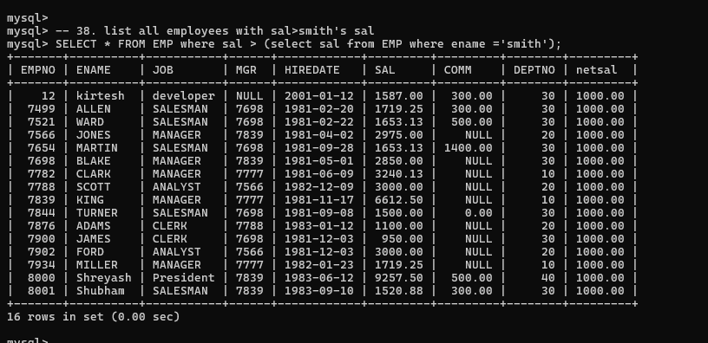-- 39. list all employees who are working in smith's department

SELECT * from EMP where deptno = (select deptno from EMP where ename ='SMITH');
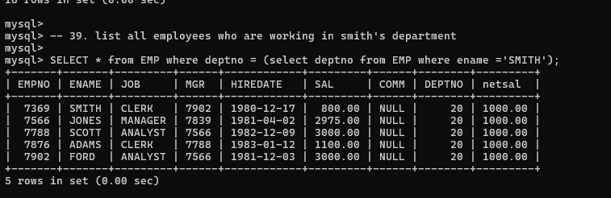
-- 40. list all employees with sal < rajan's sal and salary > revati's sal
SELECT * from EMP WHERE sal BETWEEN (select sal from EMP where ename = 'rajan') and (select sal from EMP where ename= 'revati');
-- 41. delete all employees working in alan's department

DELETE from EMP
where deptno in
(select deptno from (select deptno from EMP where ename = 'alan') as temp);
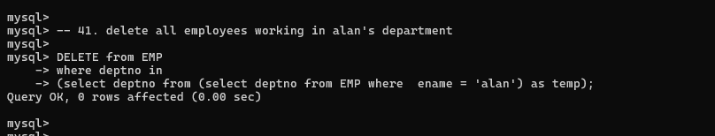
-- 42. change salary of Alan to the salary of Miller.
UPDATE EMP
set
sal =( select sal from (select sal from EMP where ename = 'miller') as temp)
WHERE ename = 'Allen';
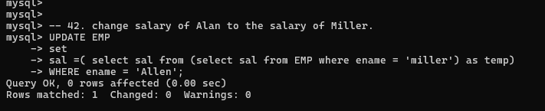
-- 43. change salary of all emplees who working in Wall's department to the salary of Miller.
UPDATE
EMP
SET
sal = (select sal from (select sal from EMP where ename = 'miller') as temp)
where deptno in (select deptno from (select deptno from EMP where ename = 'wall') as temp2);
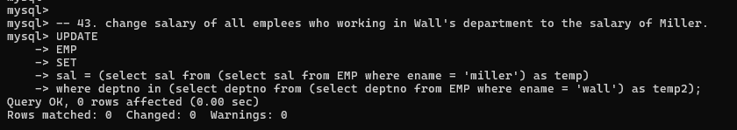
-- 44. list all employees with salary > either Smith's salary or alan's sal

UPDATE EMP
SET sal = ()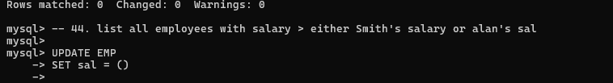
-- 45. list all employees who earn more than average sal of dept 10
select * from EMP where sal > (SELECT AVG(sal) from EMP where deptno=10);

-- 46. list all employees who earn more than average sal of Alan's department
SELECT * from EMP WHERE sal > (select AVG(sal) from EMP where deptno = (SELECT deptno FROM EMP where ename = "ALLEN"));
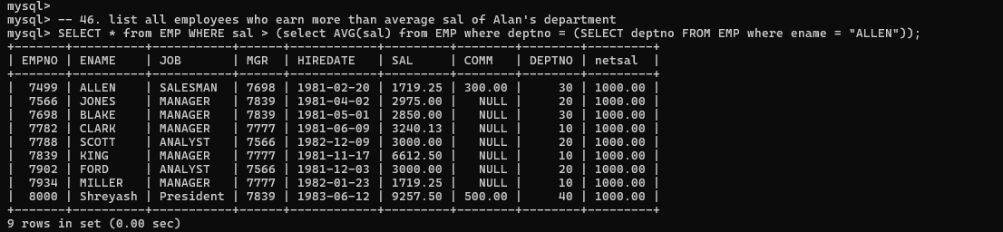
-- 47. list all employees who are working in purchase department
-- select * from EMP where deptno = (select deptno from DEPT where dname='PURCHASE');
select * from EMP where deptno = (select deptno from DEPT where dname='ACCOUNTING');

-- 48. list all employees who earn more than average salary of their own department
SELECT * from EMP e WHERE e.sal > (select AVG(sal) from EMP e1 where e.deptno =e1.deptno);
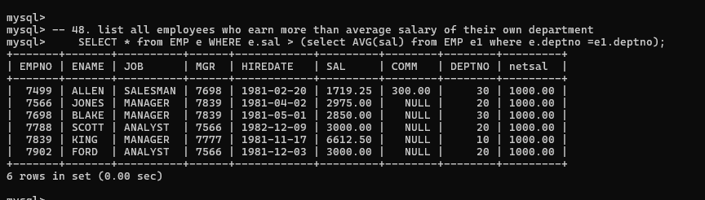

-- 49. list all employees who earn sal < than their managers salary

select * from EMP e where sal < (select sal from EMP e1 where e.mgr=e1.empno );
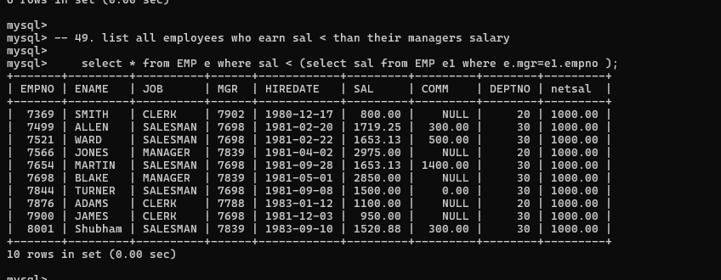-- 50. list all employees who are earning more than average salary of their job
select * from EMP e where sal > (select AVG(sal) from emp e1 where e.job =e1.job);
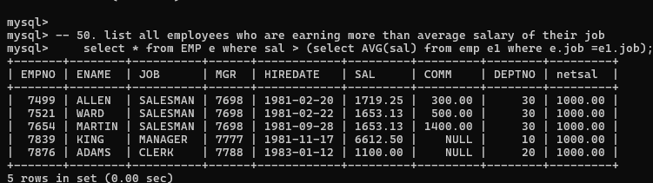
-- 51. display employee name and department

select e.ename , d.dname from EMP e,DEPT d where e.deptno=d.deptno;
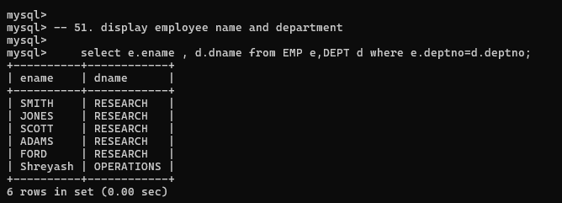-- 52. display empno,name,department name and grade (use emp,dept and salgrade table)
select e.empno , e.ename ,d.dname ,s.grade
from EMP e inner join
DEPT d on e.deptno = d.deptno
inner join salgrade s on e.sal between s.losal and s.hisal;
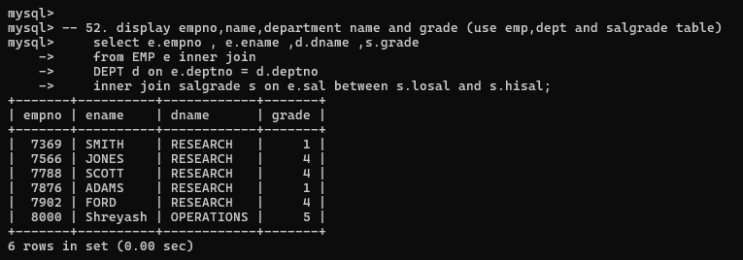
-- 53. list all employees number,name, mgrno and manager name
select e.empno,e.ename , e.mgr, m.ename from EMP e inner join emp m
on e.mgr = m.empno;

